**REACT**

React state

React hooks

npx create-react-app my-app => to create an basic react app in vs code terminal

================================

Folder Structure

package.json => list of dependencies used

public/index.html = > only html file used <div id=’root’> used by react to render

src/index.js => starting which renders the “App” component

App.js => Main Compnonet which renders sub component

================================

Each component is imported into App.js file using

import {ComponentFunctionName} from path;

And then calling the component by < ComponentFunctionName ></ComponentFunctionName >

In the file contianting component it should be like

export ComponentFunctionName = () =>{

return(

<div>

<p></p>

</div>

);

};

NOTES:

* Return should mainly contain only one tag(so we use div under which we can use other tags)
* ComponentFunctionName first Letter should be in Capital
* For default exported ComponentFunctionName we should not use use Curly braces during import i.e. import DefaultComponentFunctionName from path;

===============

**JSX**

To use any expression or replace with javascript values we use curly braces “{}”

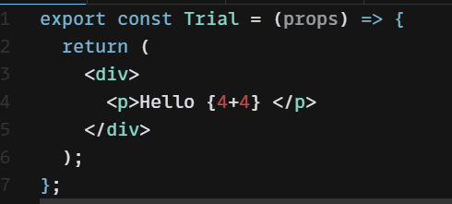

==========================

**PROPS**

While calling component tag if we give any attributes then it will be passed as props to component example:

In App.js

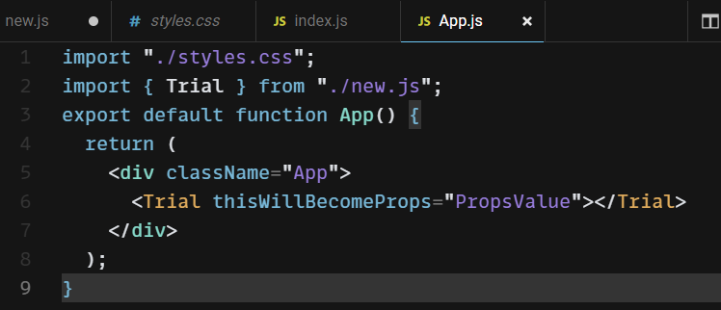

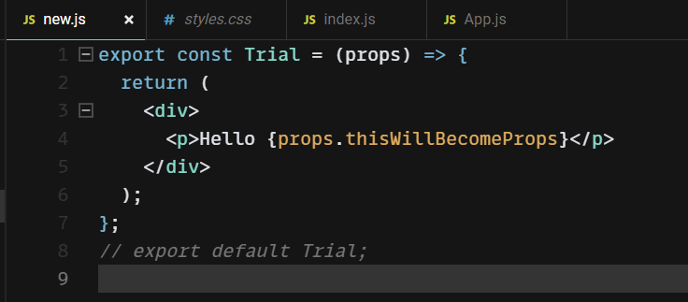

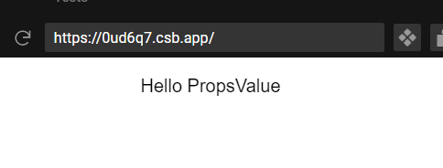

Props.children is used to access values passed between compnent tag i.e. between <ComponentName></ComponentName>

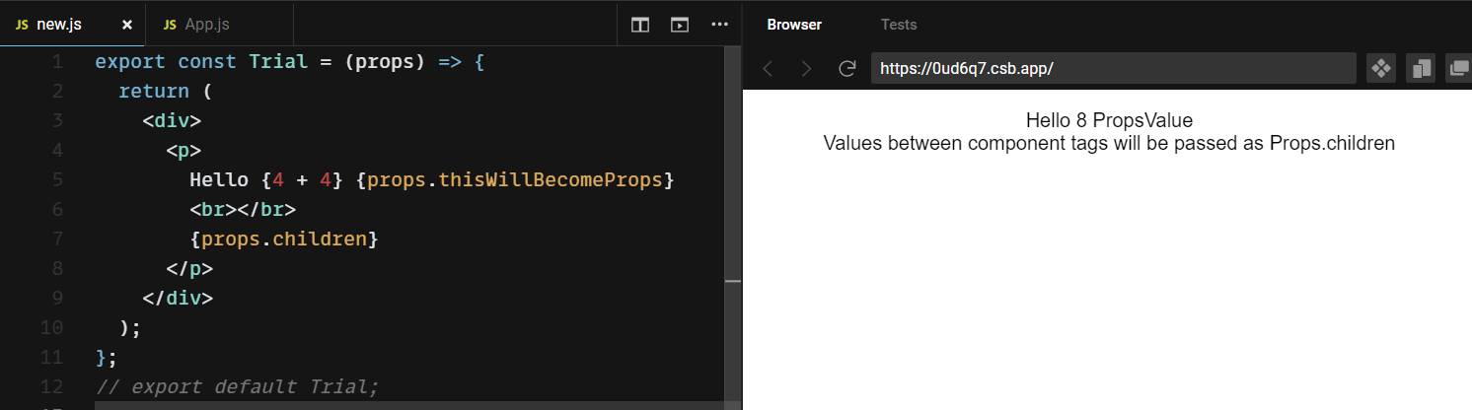

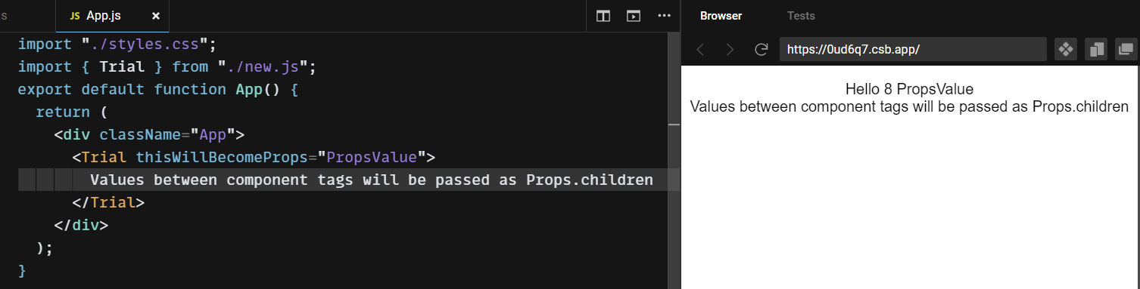

=====================

**USESTATE HOOK = LOCAL VARIABLE**

Syntax:

var/const [variableName,functionTosetNewValue] = useState(DefaultValue);

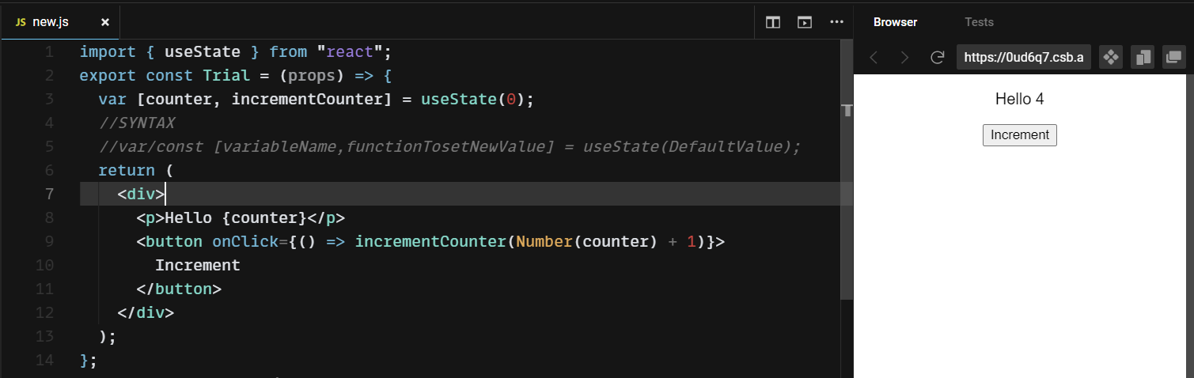

OTHER WAY TO DECLARE

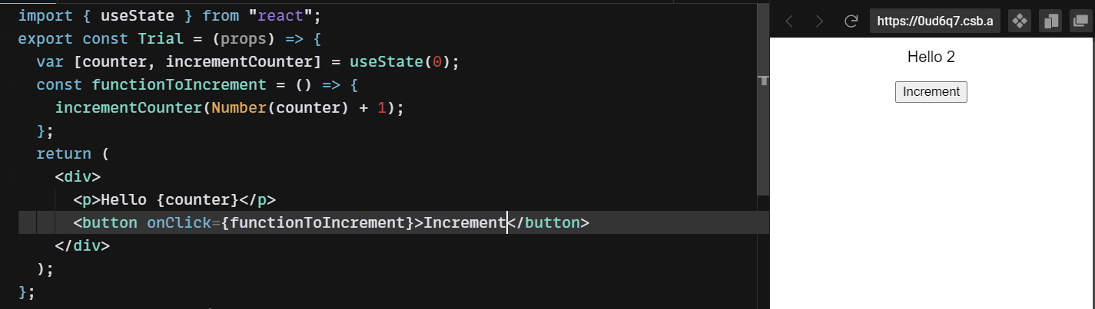

===========

=====================

**EVENTS AND FUNCTIONS:**

onClick, onMouseHover etc. equivalent to JavaScript Events but in CamelCase

Note there is no parentheses next to this events in JSX

Syntax

<button or whatever onClick={functionName}>

<button or whatever onClick={(ArrowfunctionArguements) = > {Work Done}}>

<button or whatever onClick={(event) = > {functionName(event,other arguements)}}>

NOTE NEVER USE ANY DIRECT FUNCTION CALLS FOR EVENTS (AN EXAMPLE WOULD BE UPDATING usState_variable value using directly UseStateUpdateFunction)

NOTE IN FIRST SYNTAX WHICH S JUST FUNCTIONNAME NEVER USE () AFTER FUNCTIONNAME;

IF YOU WANT TO SEND SOMETHING TO FUNCTION USE TYPE 3 SYNTAX WITHOUT “event” i.e.

<button or whatever onClick={(args) = > {functionName(args)}}>

ALWAYS ENSURE => is next to ()

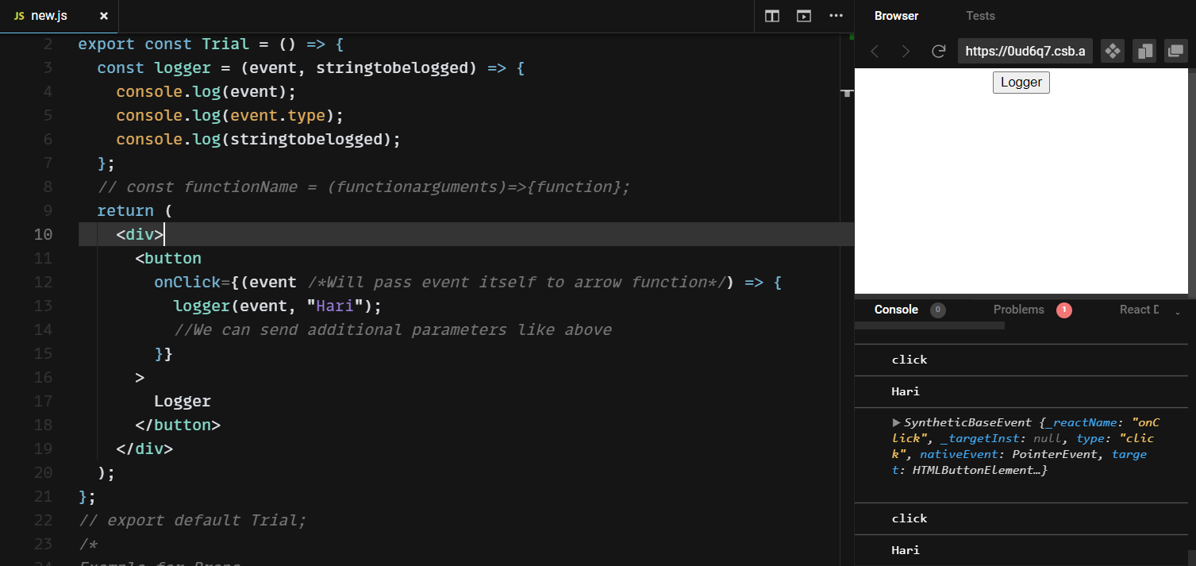

=====================

=====================

**PARENT CHILD COMMUNICATION**

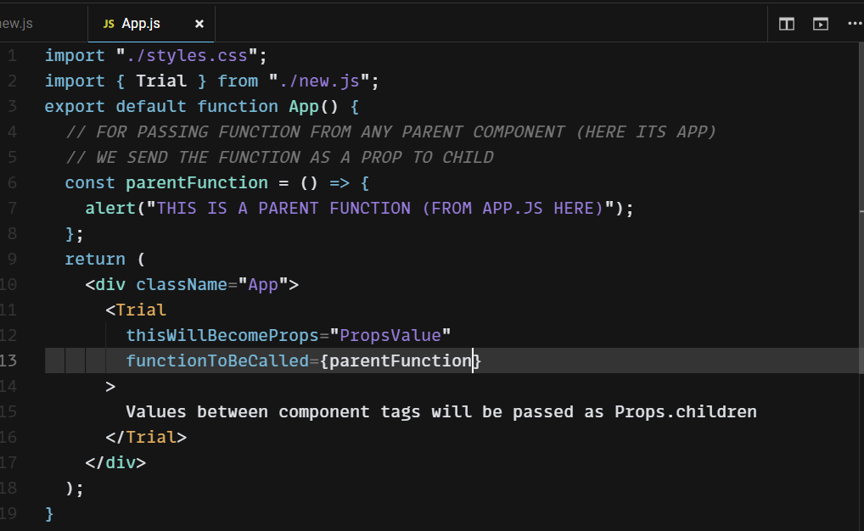

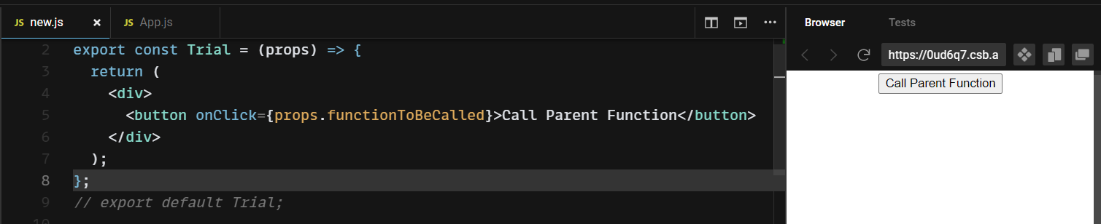

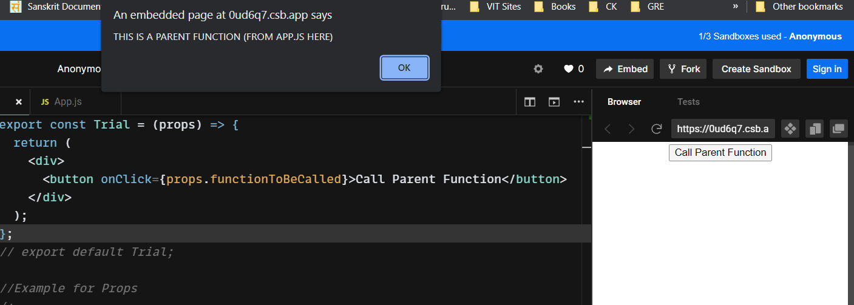

FOR PASSING ARGUMENTS TO PARENTS:

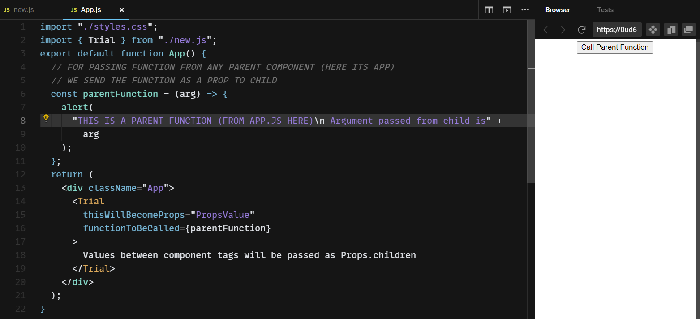

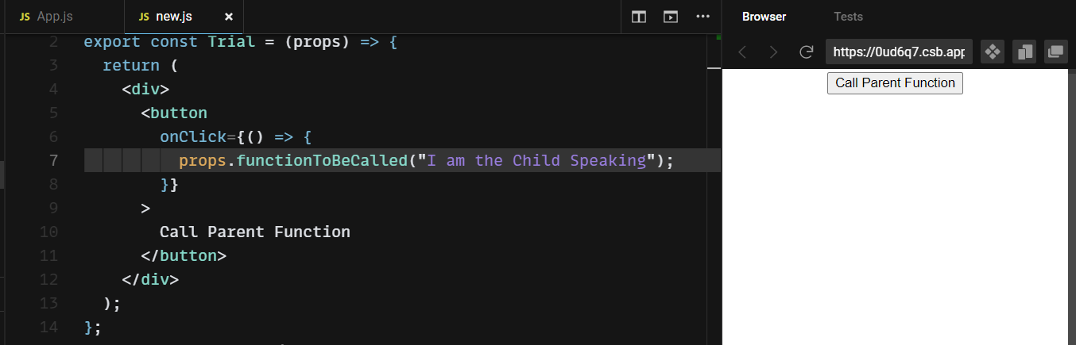

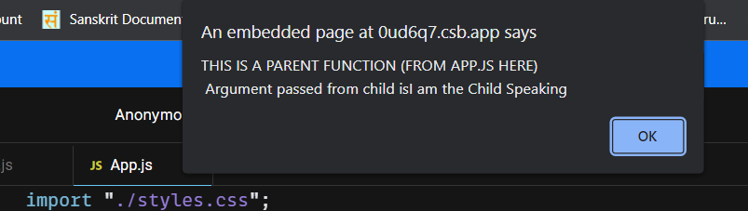

=====================

**CONDITIONAL RENDERING**

TERNARY OPERATOR USED IN {} TO RETURN VALUES

FORMAT {expression/value ? return_if_true : return_if_false}

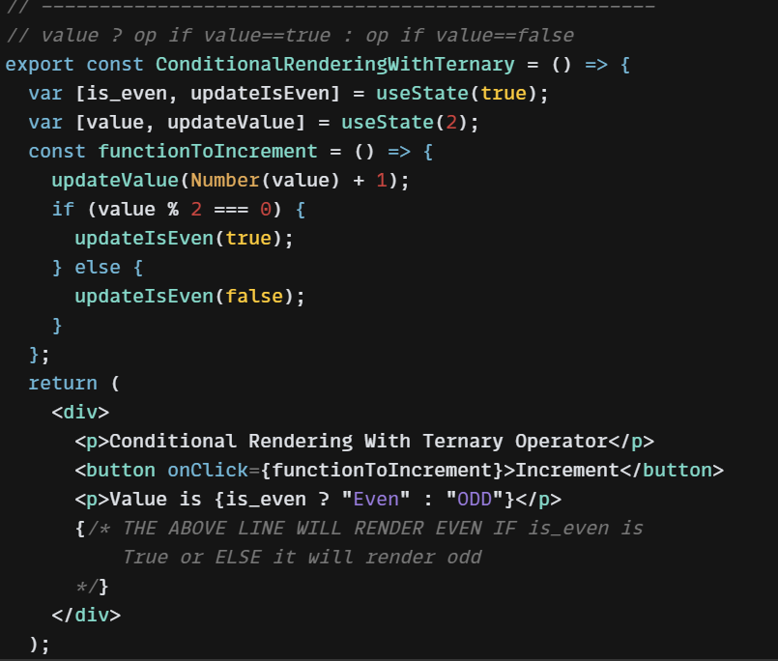

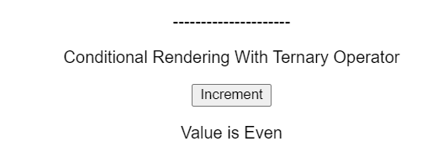

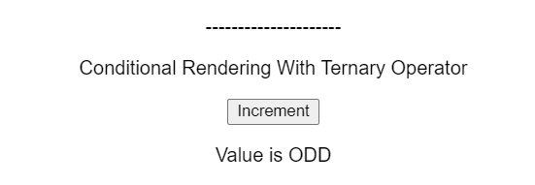

SHORT CIRCUIT

&& = > evaluates left hand side and does right hand sideonly if lhs is true

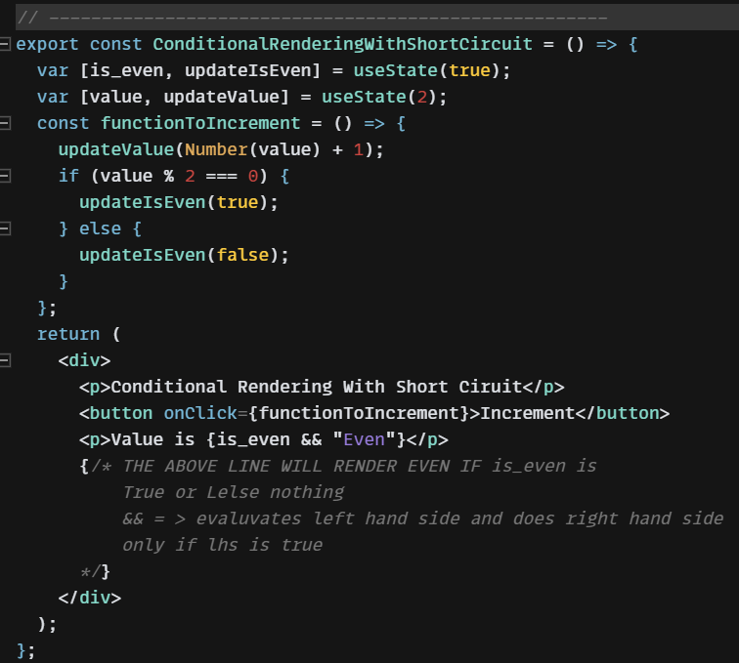



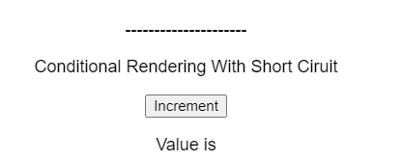

=====================

**LIST RENDERING**

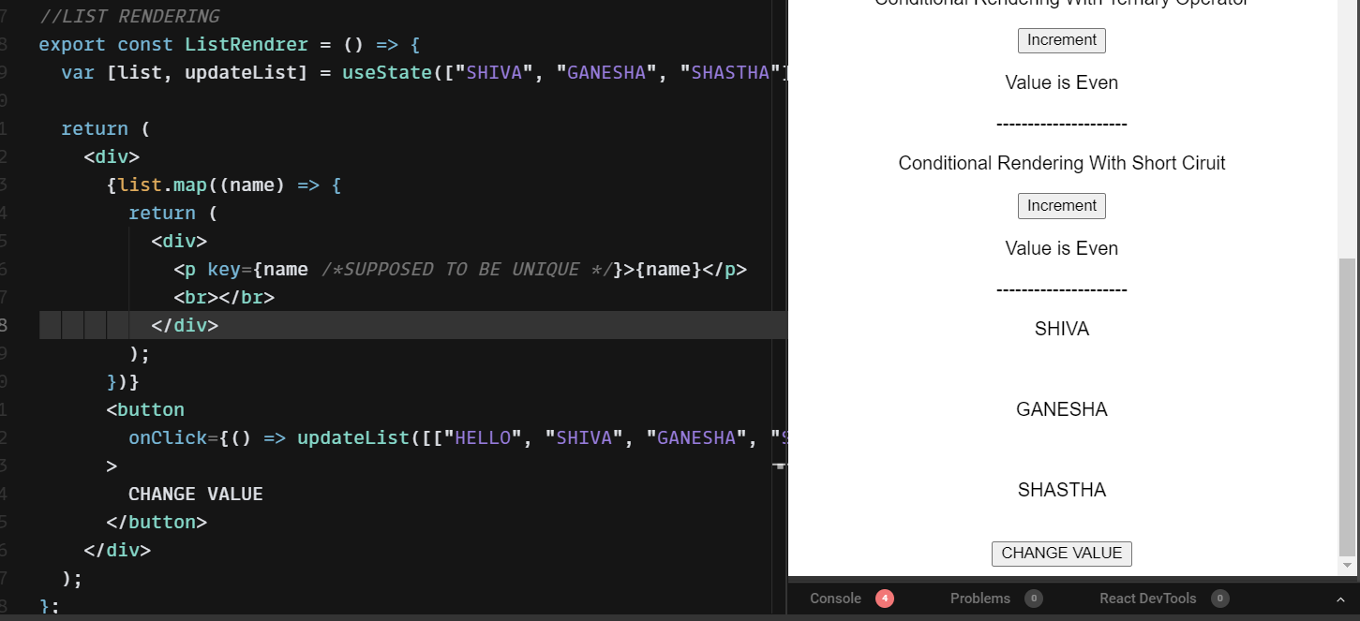

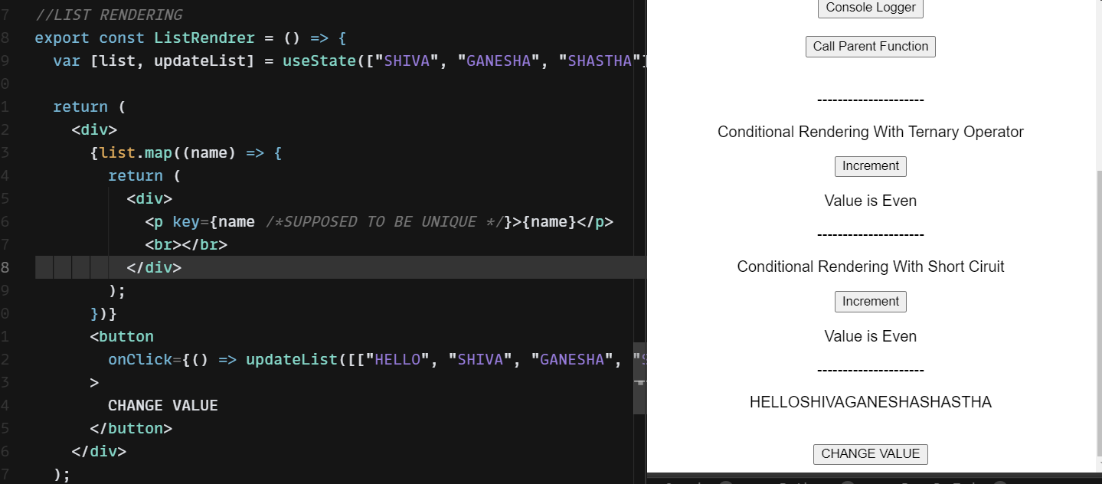

=====================

**STYLING**

Import the css file in the js file using import statement

STYLES IN COMPONENT AND INLNIE

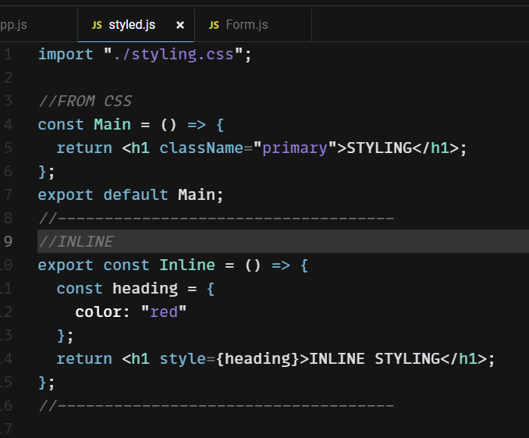

STYLESHEETS IN APP.js

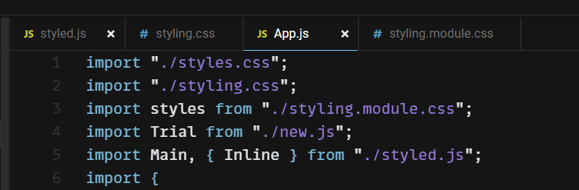

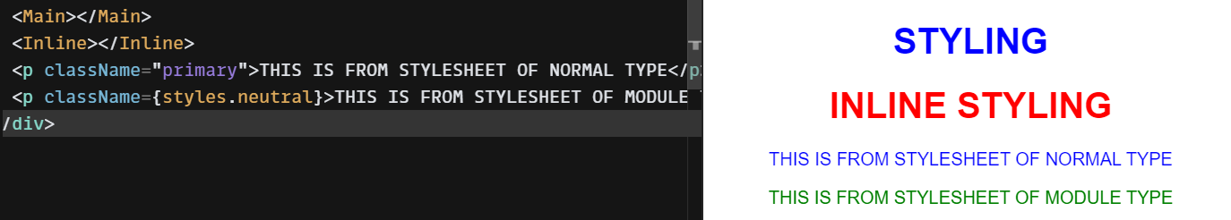

=====================

**FORMS**

Values of input tags would be useState variables

IF WE DONT USE onChange then input changes wont be reflected

For onChange we can use

1. {(event) = > functionName(event parameter,other parameters)} //SEE USERNAME EXAMPLE
2. {directUseStateChangeVariableFunction(event.target.value)} //SEE PASSWORD EXAMPLE=>DON’T USE THIS AS IT CAUSE MANY RERENDERS
3. {FunctionName}//SEE PHNO EXAMPLE

FOR OBJECTS ALONE WHILE ASSIGING IN directUseStateChangeVariableFunction({…useState_variable, property_to_be_added_or_changed : event.target.value})

property_to_be_added_or_changed would be in [] if the name from the input tag is used as shown in “defaultOnChangeFunction” in below Example (Form.js in code)

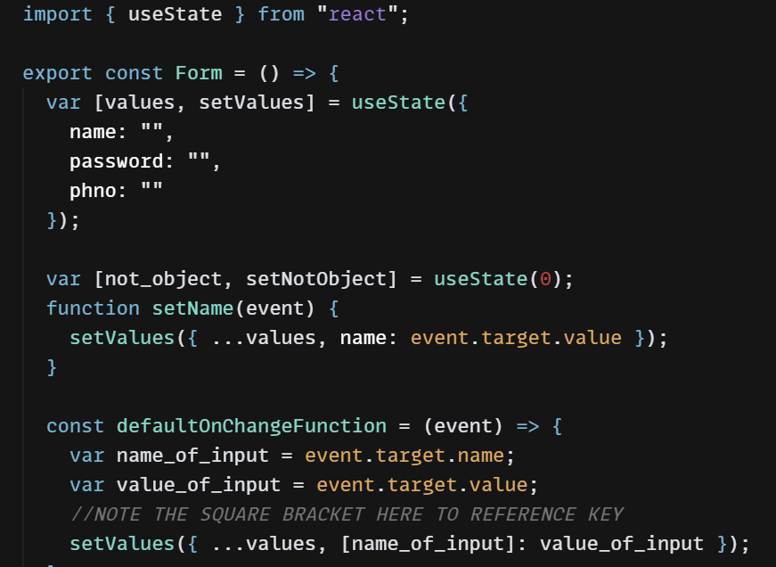

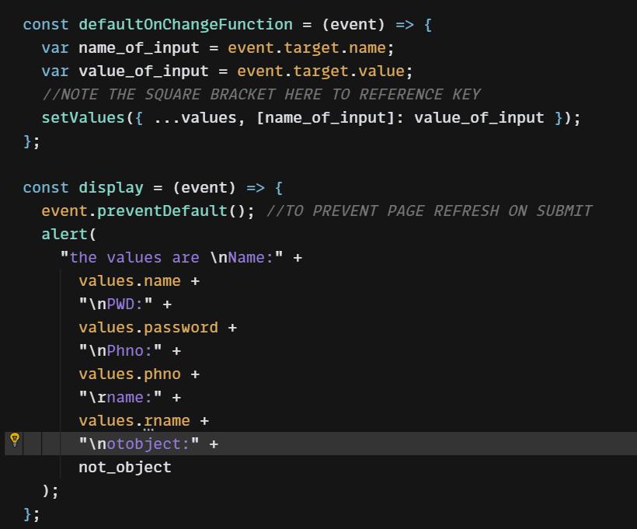

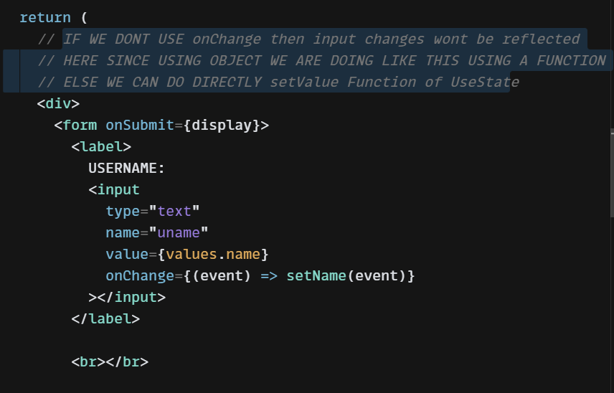

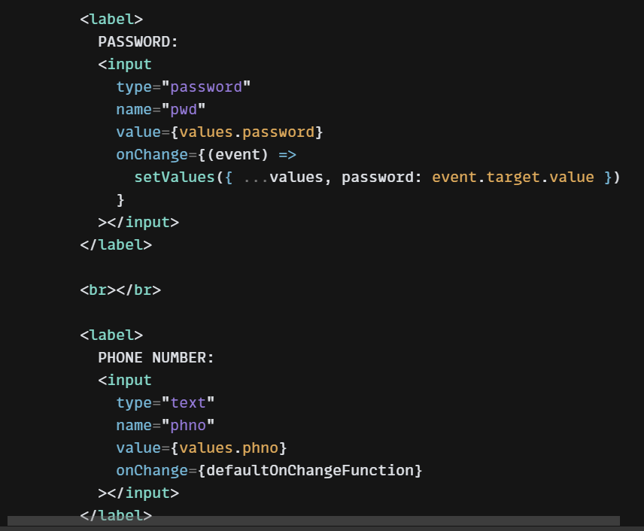

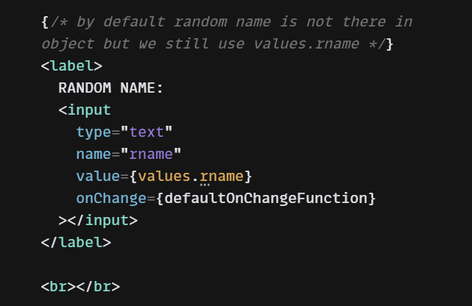

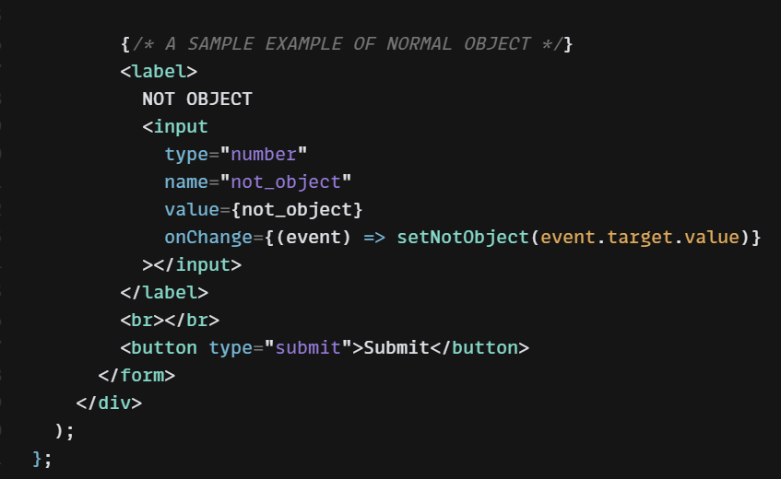

=====================

**)API CALLS USING FETCH (GET AND POST)**

USING FETCH:

FOR GET USING then:

//FOR GET USING FUNCTION INSTEAD OF useEffect refer to axios part

fetch(url)

.then( (response) =>{ response.json()})

.then((data)=> updateUseState(data)).catch().finally()

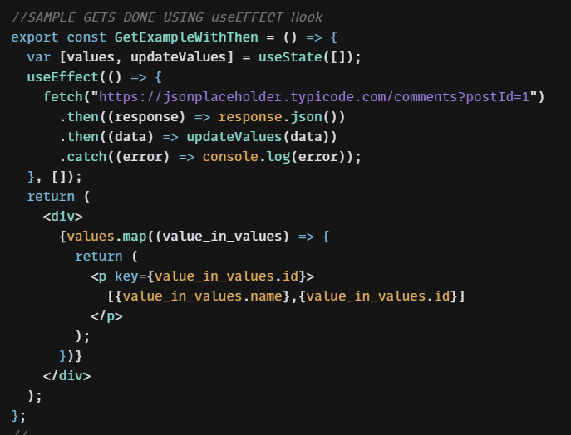

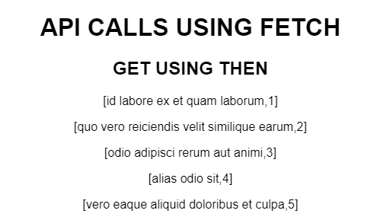

FOR POST USING then:

fetch(‘url’, {

method: 'POST',

body: JSON.stringify(values)//can be either object or list of objects

headers: {

'Content-type': 'application/json; charset=UTF-8',

},

})

.then((response) => response.json())

.then((json) => console.log(json));

FOR GET USING async and await:

async function () OR const function= ()=> {

var response = await fetch("url");

updateValues(await response.json());

}

}

NOTE WHILE USING useEffect: async should be for another function within the arrow funcition

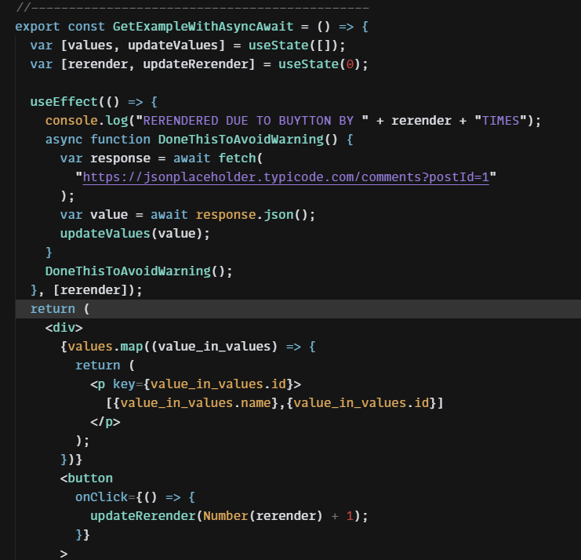

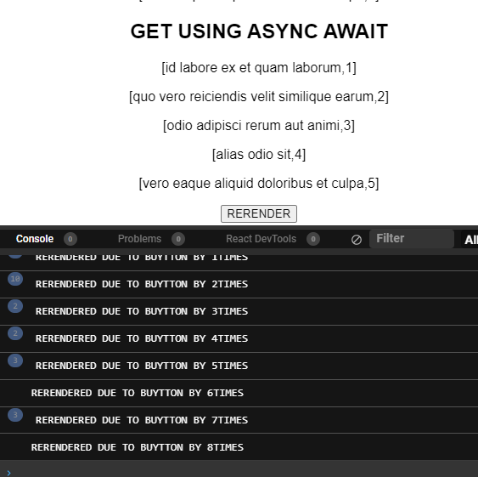

FOR POST USING then:

fetch("url", {

method: "POST",

body: JSON.stringify(values),

headers: {

"Content-type": "application/json; charset=UTF-8"

}

})

.then((response) => response.json())

.then((json) => console.log(json))

.catch((error) => console.error(error))

.finally(alert("Done"));

};

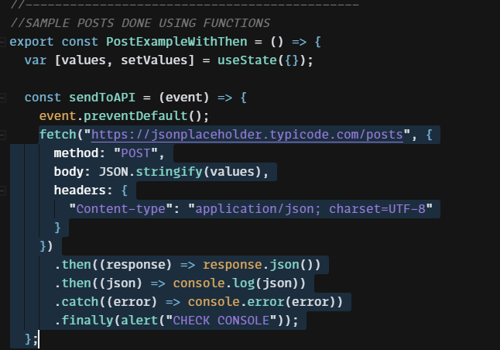

FOR POST USING async:

try {

var response = await fetch("url", {

method: "POST",

body: JSON.stringify(values),

headers: {

"Content-type": "application/json; charset=UTF-8"

}

});

console.log(await response.json());

} catch (error) {

console.error(error);

} finally {

alert("CHECK CONSOLE");

}

};

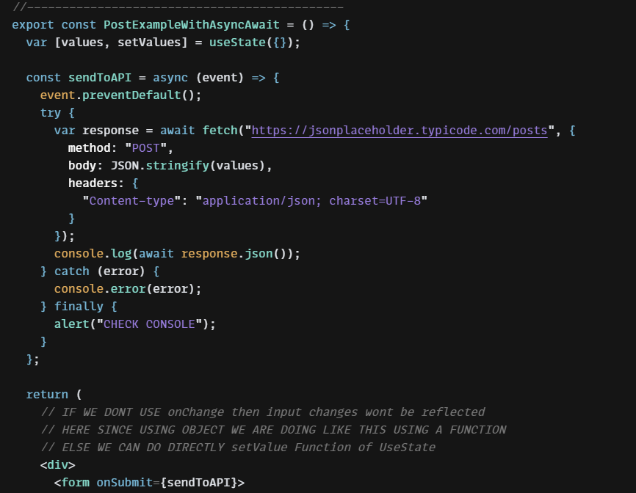

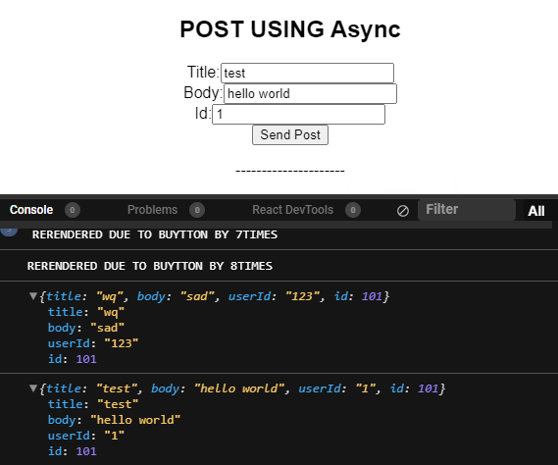

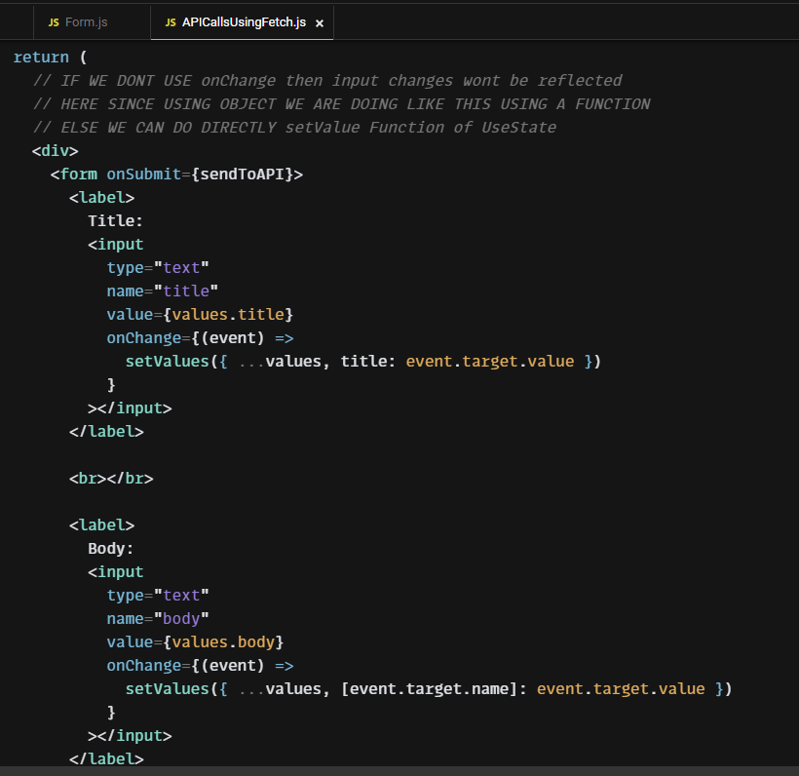

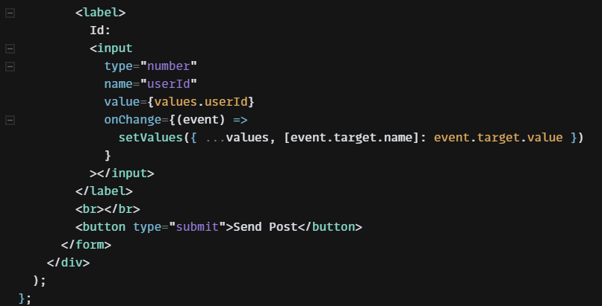

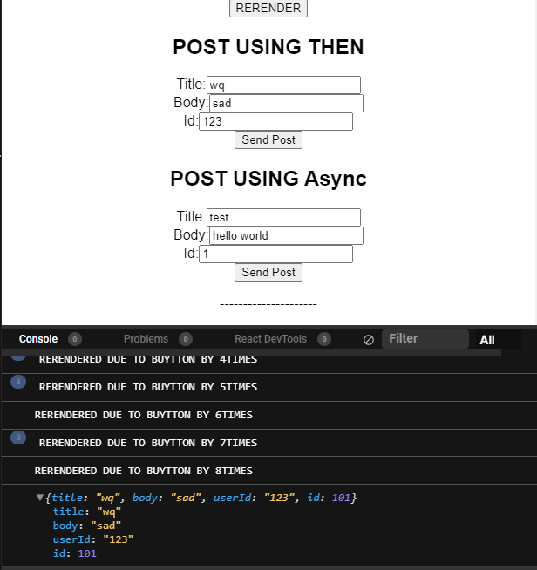

=====================

**API CALLS USING AXIOS (GET AND POST)**

Install:

npm install axios

Syntax:

import axios from "axios";

//USED TO CREATE BASE OBJECT TO BE USED IN OTHER COMPONENTS

export default axios.create({

baseURL: "url",

headers: {

"Content-type": "application/json; charset=UTF-8"

}

});

//ANY URL GIVEN TO THE IMPORTED OBJECYT WOULD BE APPENDED WITH/

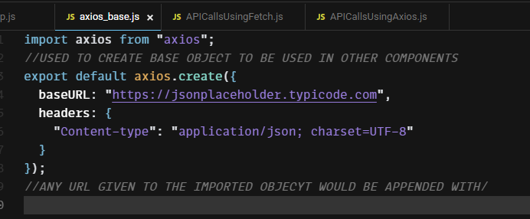

axios.get(url,[config])

axios.post(url,[data,config])

axios.put(url,[data,config])

axios.patch(url,[data,config])

axios.delete(url,[data,config])

NOTE RESPONSES ARE FORM OF OBJECT (SEE POST CONSOLE FOR OUTPUT EXAMPLE)

GET WITH Then

axios

.get("https://jsonplaceholder.typicode.com/comments?postId=1")

.then((response) => updateValues(response.data))

.catch((error) => console.log(error));

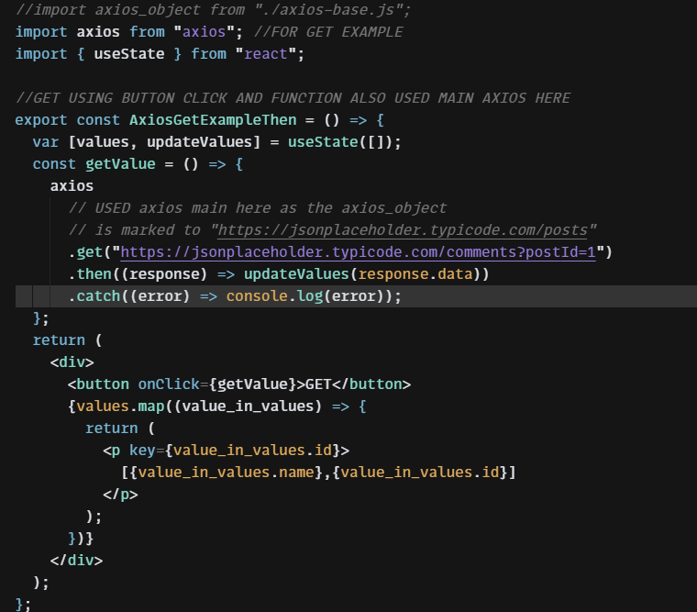

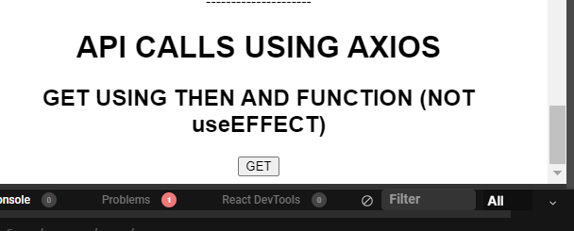

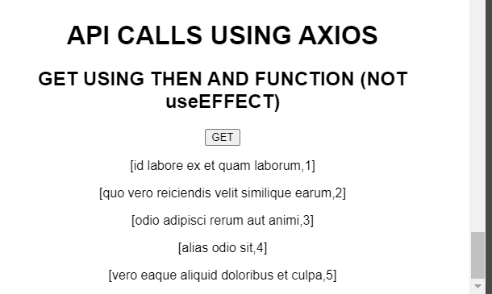

POST WITH Async Await(NOTE USING AXIOS OBJECT HERE)

const sendToAPI = async (event) => {

event.preventDefault();

try {

var response = await axios_object.post("appended url", values)

// appended url would becoem “baseUrl/ appended url”

console.log(response);

} catch (error) {

console.error(error);

} finally {

alert("CHECK CONSOLE");

}

};

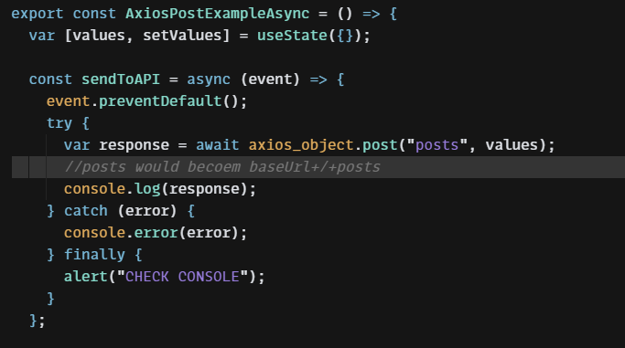

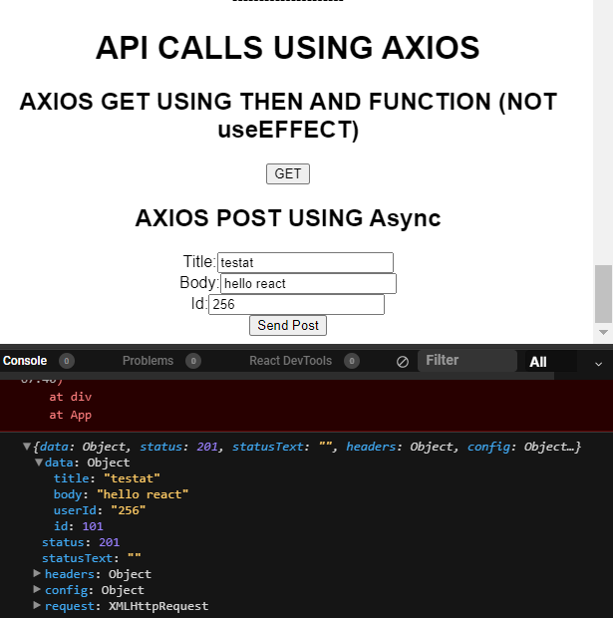

=====================

useTransition

=====================

useEffect

Syntax : useEffect( function to be done (can be arrow function),[list of useState_variables which when changed would cause the effect to fired])

Note: an empty variable list would mean run the effect once in the beginning

Note: with no list then the effect would run whenever the page is rendered i.e. for many time per change in page

Example:

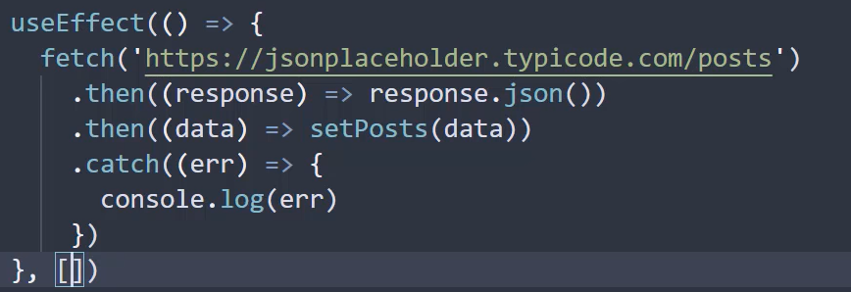

RERENDERING EXAMPLE IN USEEFFECT

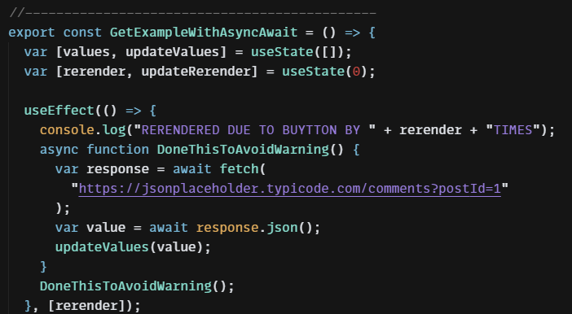

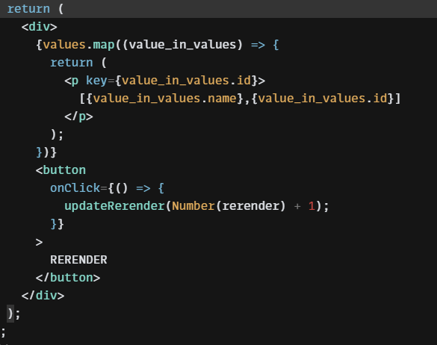

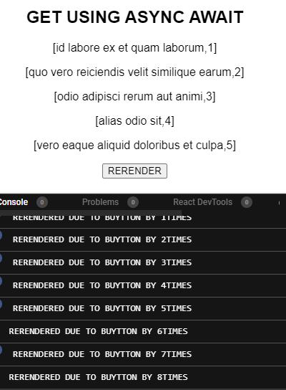

=====================

useMemo

=====================

useCallback

=====================

CUSTOM HOOKS

=====================

REACT ROUTER

SANDBOX TILL PARENT CHILD COMMUNICATION: <https://codesandbox.io/s/laughing-thunder-0ud6q7>

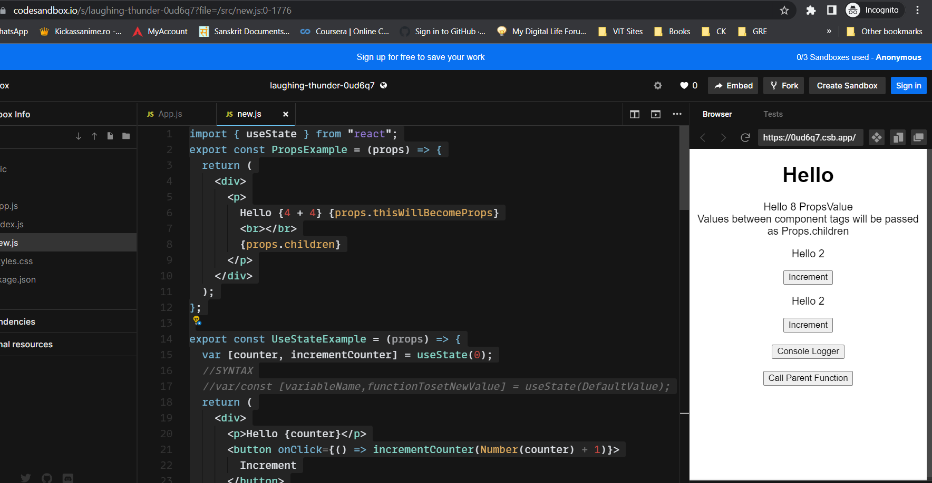

SANDBOX TILL STYLING

<https://codesandbox.io/s/vibrant-bird-hxwies>

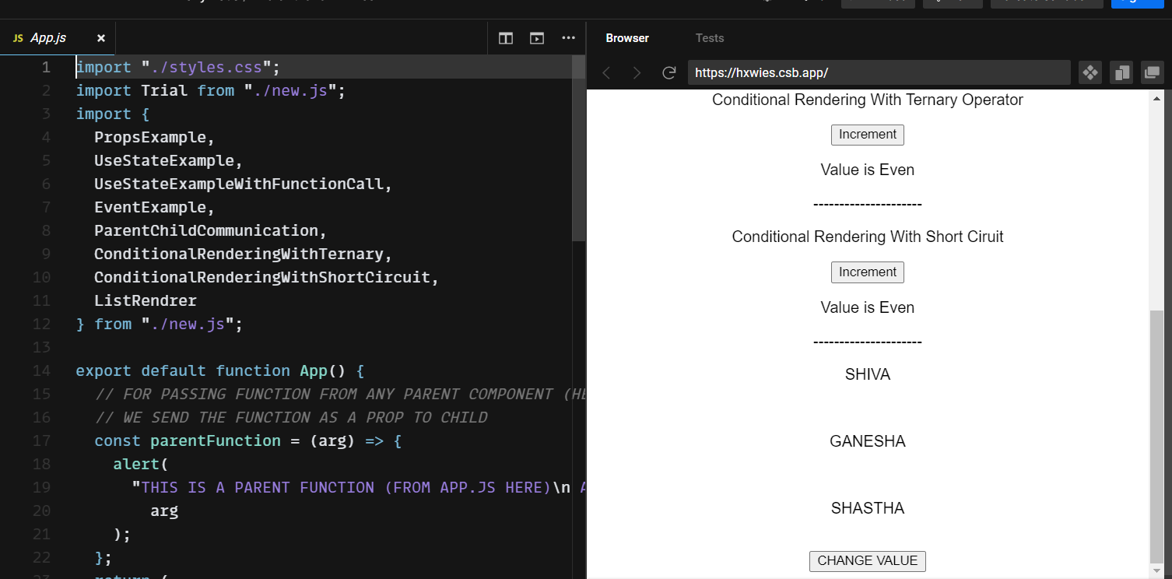

SANDBOX TILL API CALLS

<https://codesandbox.io/s/optimistic-browser-kr6lyq>

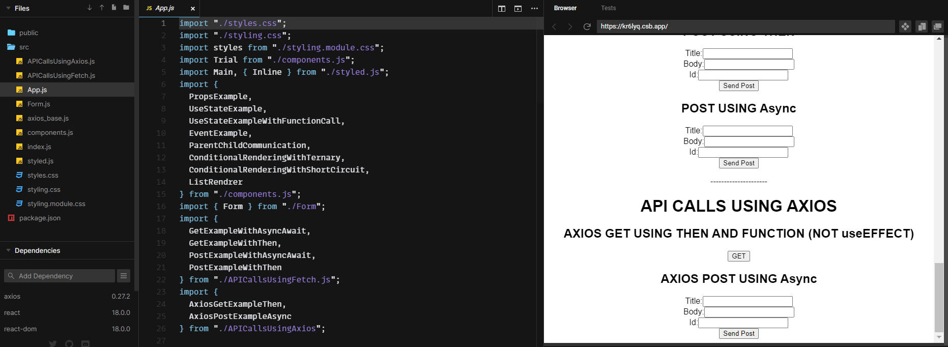

**REACT USING TYPE SCRIPT**

Npx creat-react-app appname –template typescript

**Passing Props**

Got to define props type

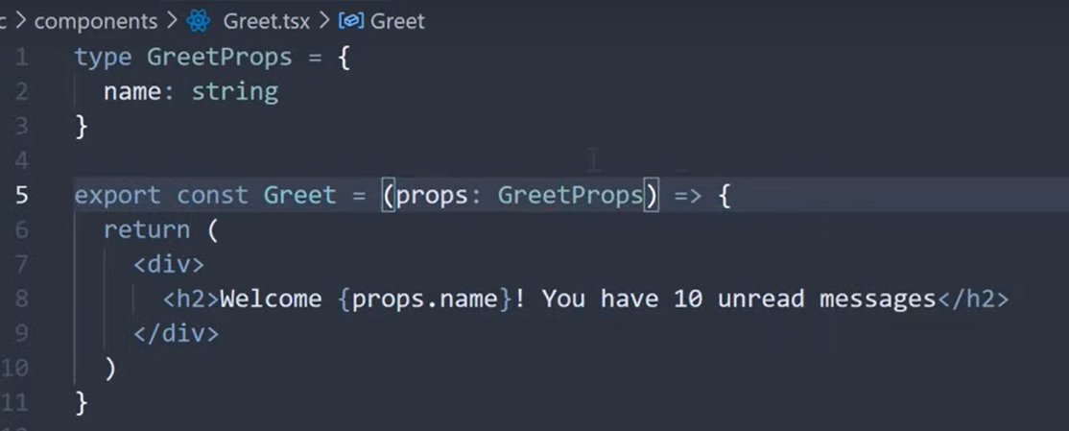

“&” is used to merge some exisitning types with some other types eg

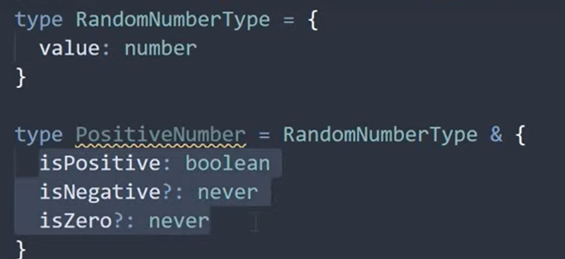

Discriminated Unions

x|y => x or y type

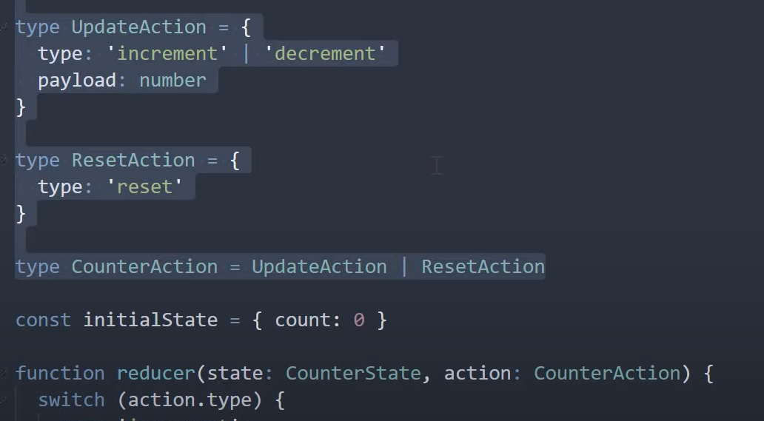

When props passed are of type object

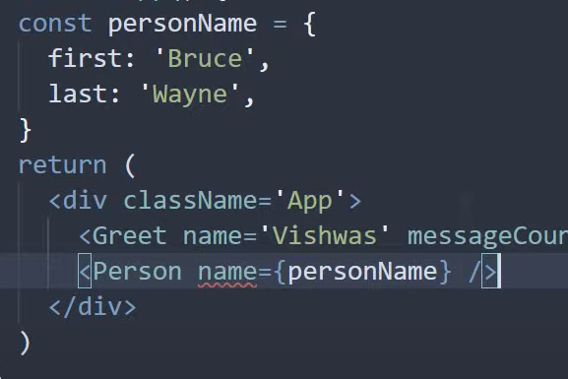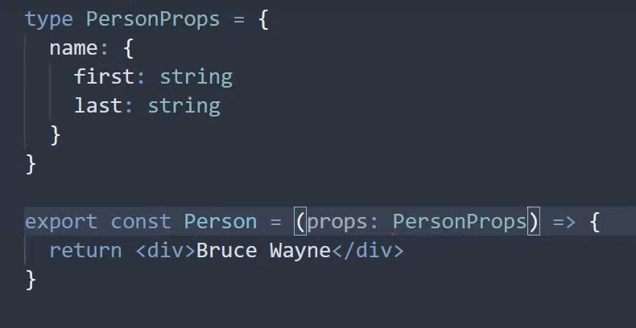

Array of Objects

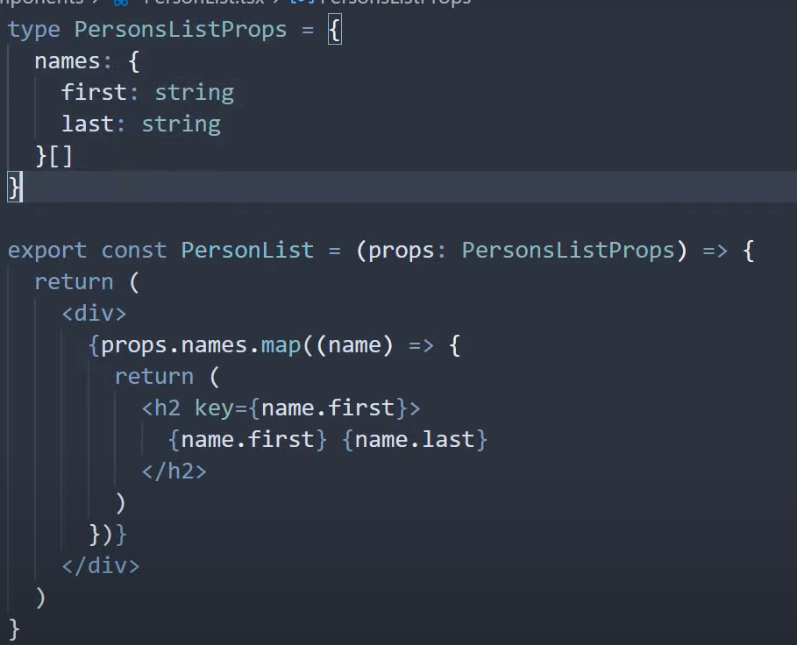

Props can have fixed type values alone instead of string eg proptype={ status : “loading”|”finished”}}

Props with children

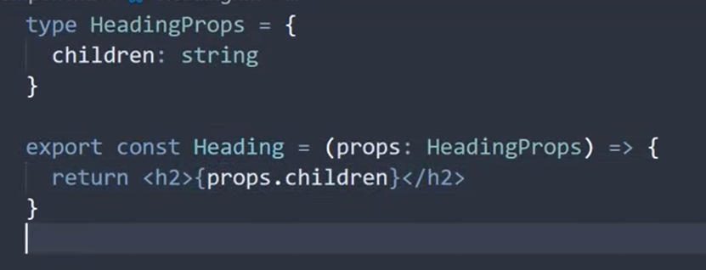

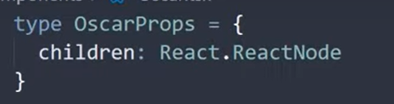

OPTIONAL PROP VALUE syntax => propvaluename ?:type

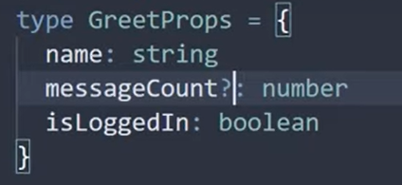

EVENT TYPE PROP (WHEN EVENT IS PASSED THORUGH PROPS)

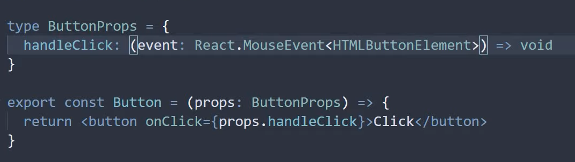

GENERIC PROP: use<T>

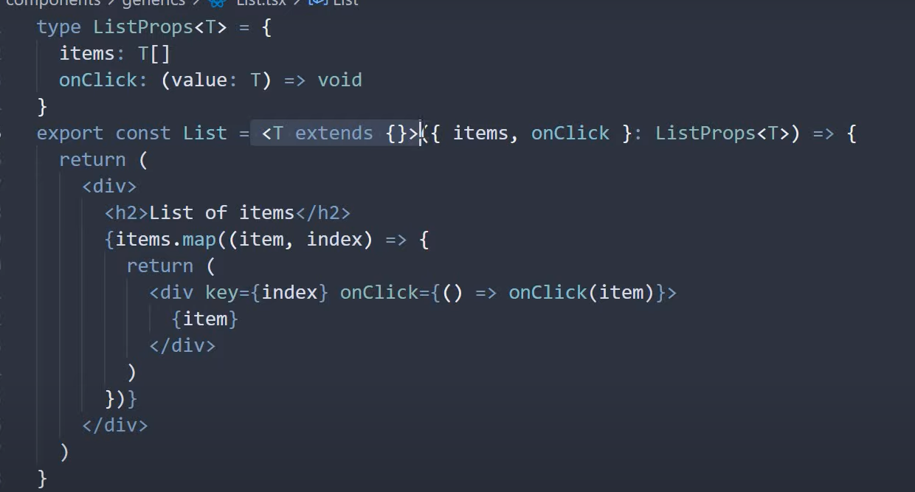

PASSING COMPONENT IN PROPS

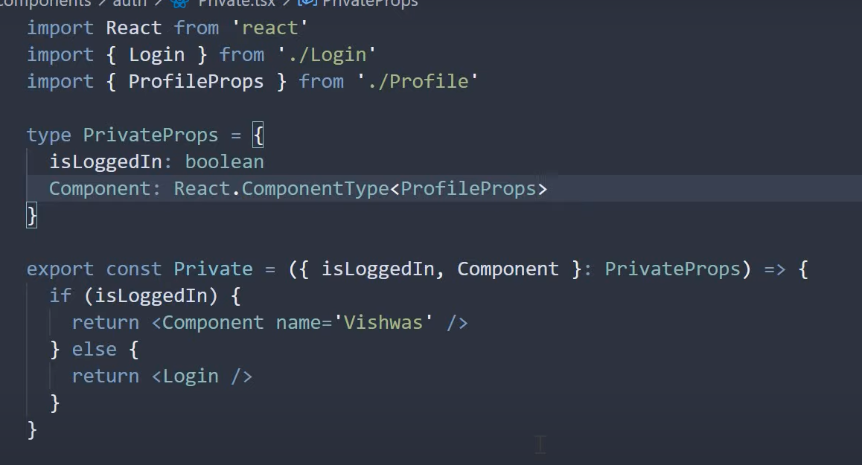

TEMPLATE LITERALS =>USED TO COMBINE STRING LITERALS

Us ticks “ ` ` ” and do necessary formatting. Exclude is used to make sure a certain type of template literal is not formed from the string

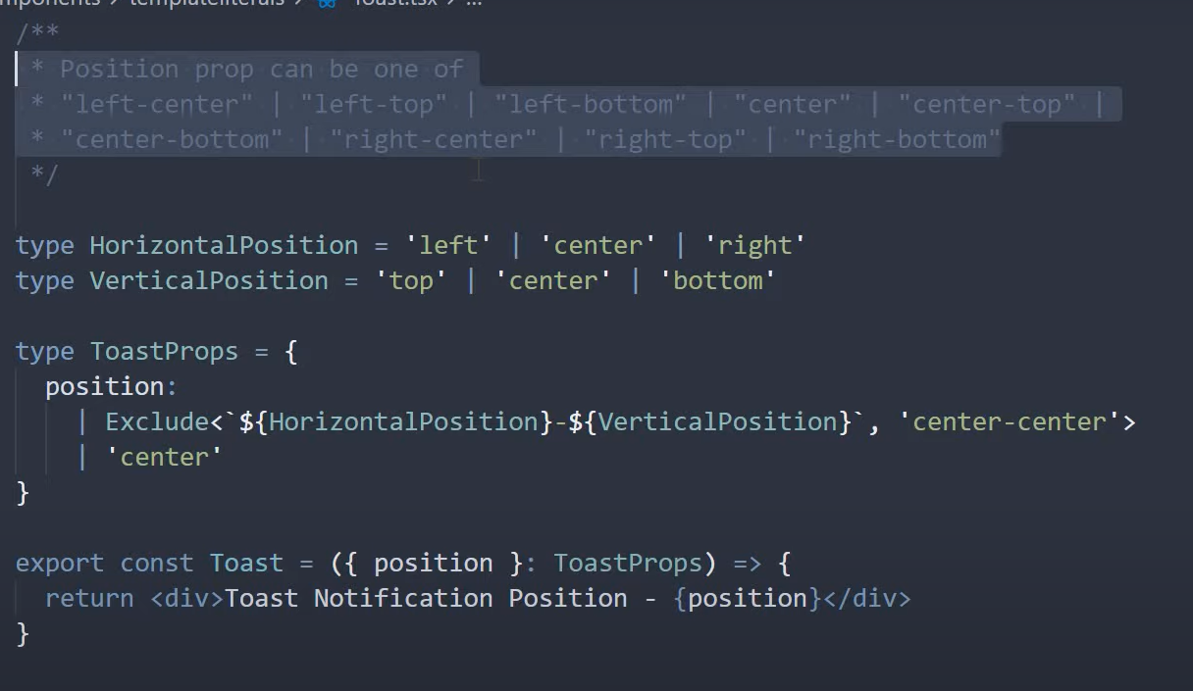

HTML ELEMENTS AS PROPS

To accomodatae components of types button etc.

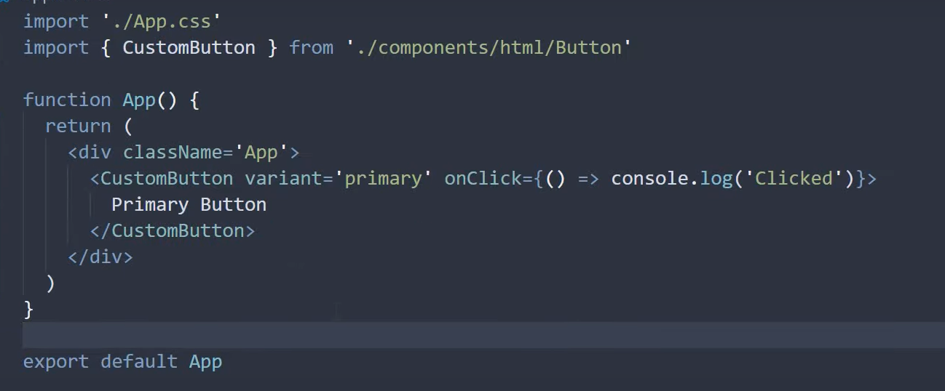

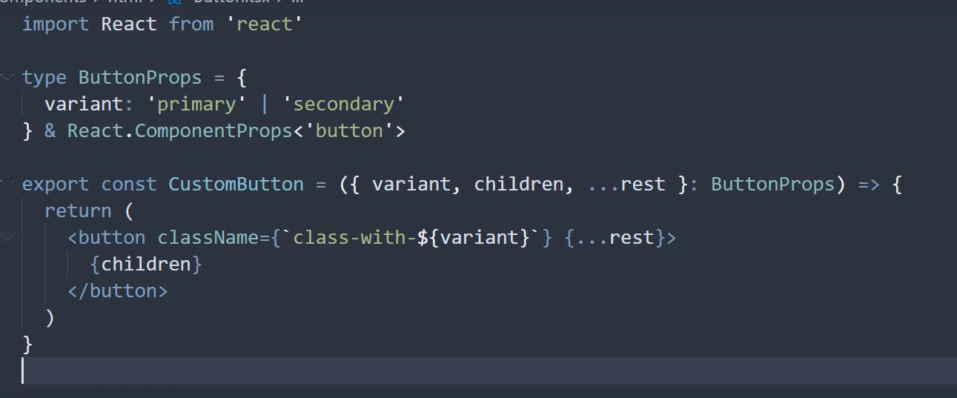

THE OMIT IS USED TO ENSURE THAT THE CHILDREN PASSED ARE NOT GIVE REACTCOMPONENTPROPS TYPE AND IS ENFORCED TO BE STRING ONLY

USEFUL FOR RESTRICTING CERTAIN THINGS IN THE BELOW CASE PASSING ONLY STRING AND NOT ANTHING ELSE

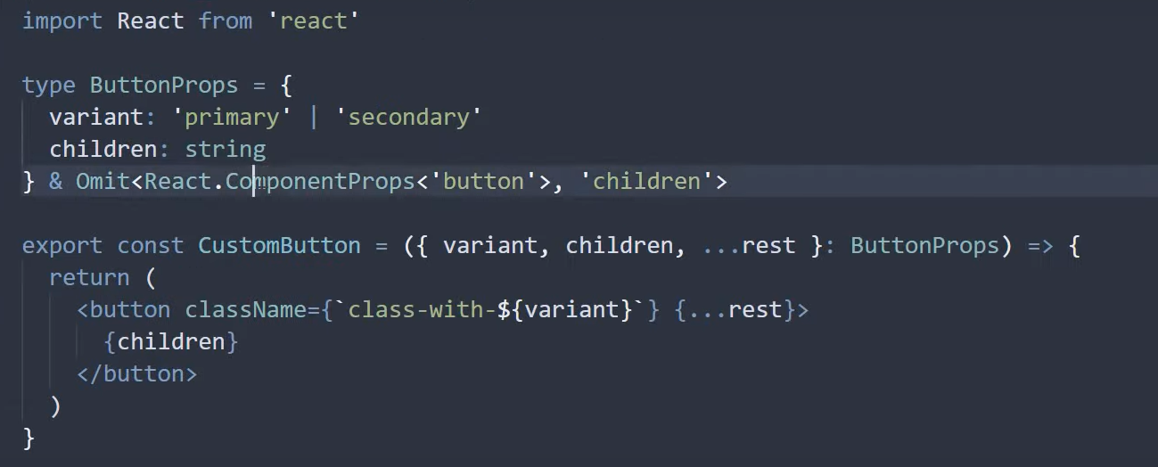

USING OTHER COMPONENT TYPES

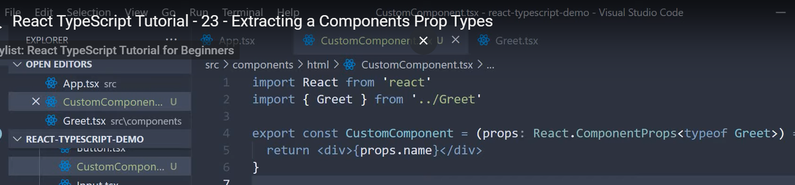

POLYMORPHIC COMPONENTS

USED TO SET VARIOUS TYPES OF HTML ELEMENTS

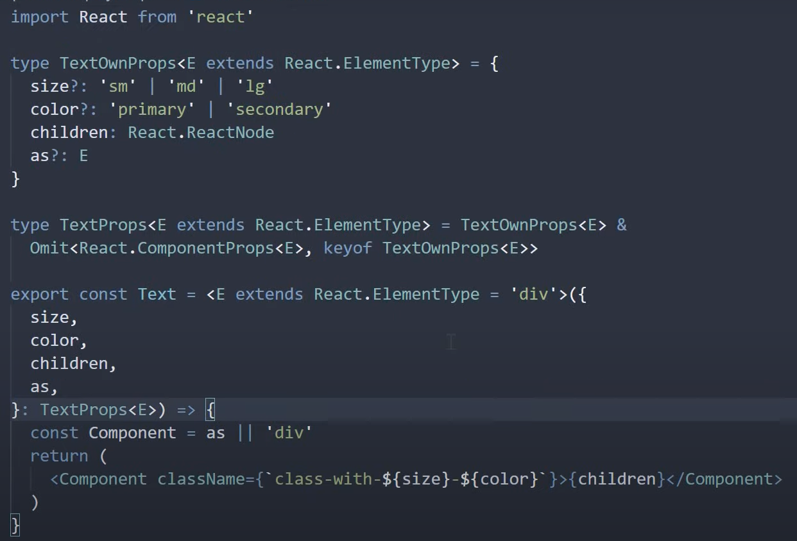

**HOOKS IN TYPESCRIPT**

**useState<typ1|type2…>(default_value)**

Note if no type is given it is inferred from default value

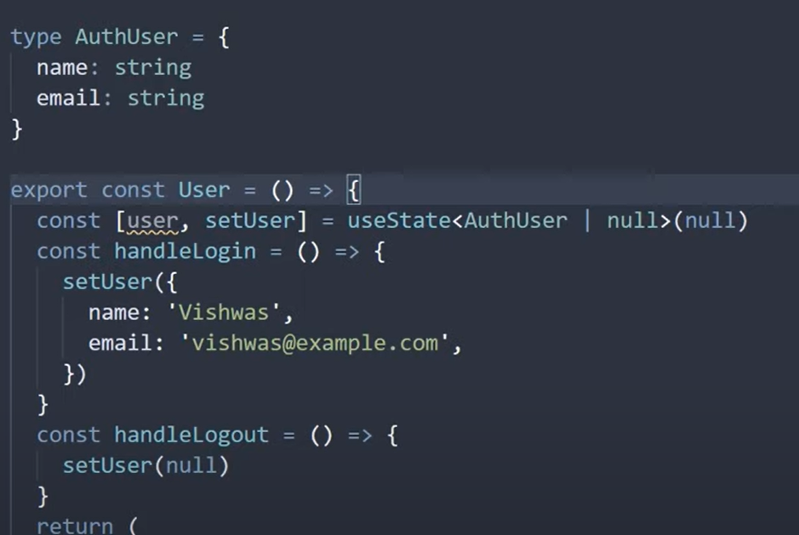

Check for object existence if value type is null by any chance

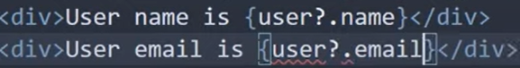

Alternate way to do the above code with state assertion (note usage of “as”)

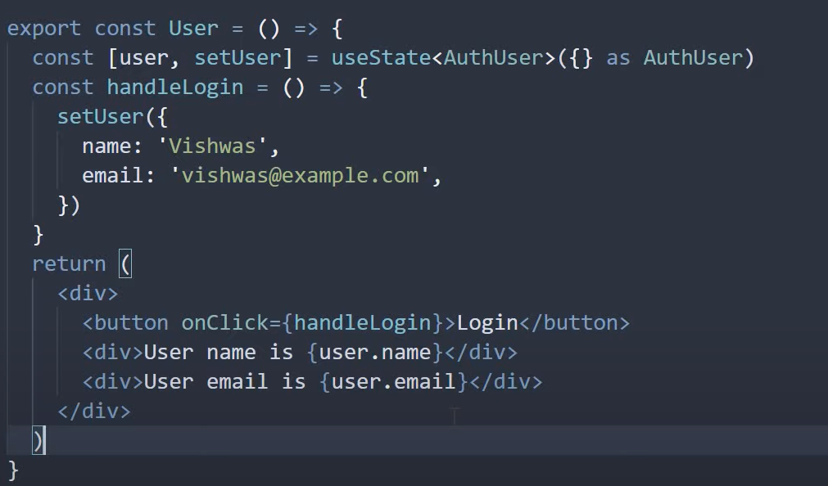

---------------------------------------------------------------------------------------------------------------

useReducer

const[state,function]=useReducer(reducer,intialState)

reducer is a function used handle changes based on the state and action passed

In the below example reducer state is obtained from existing state and action is what is passed to it. So we assign types to both of them

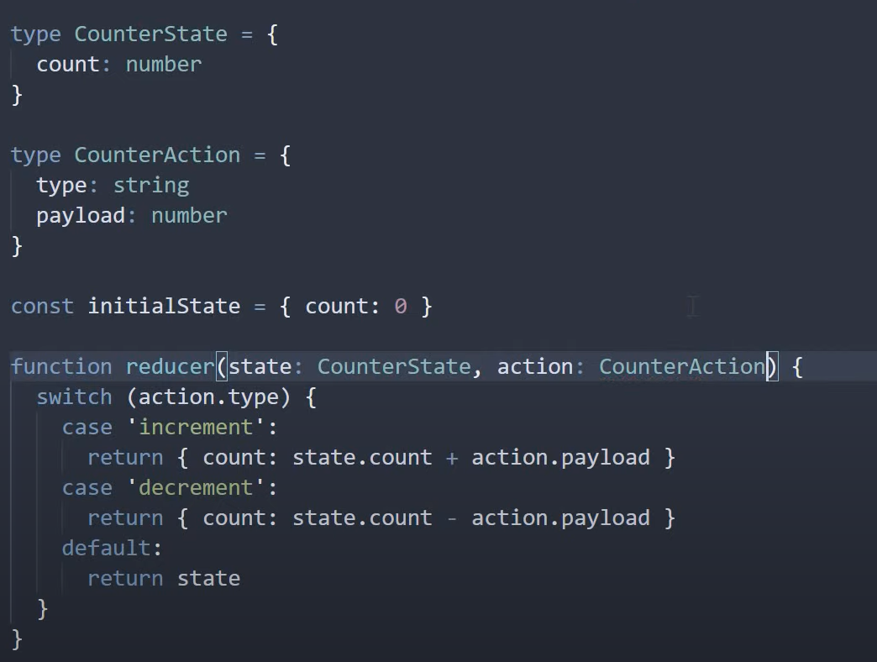

We can also use strict action types to specify only certain inputs

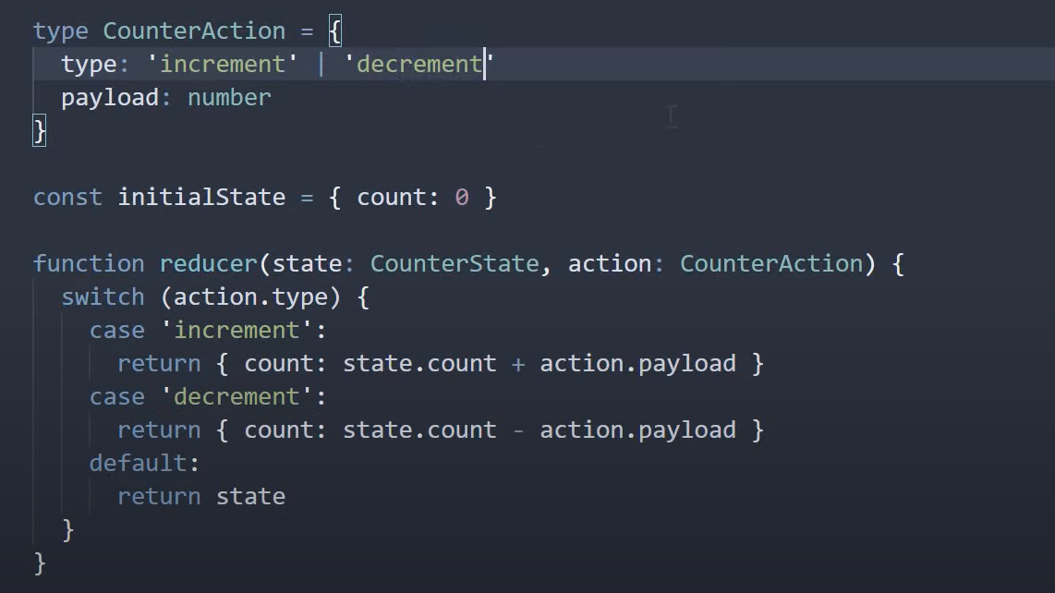

**REACT ROUTER**

index.js => Wrap <App/> with <BrowserRouter> from react-router-dom

App.js =>

<Routes>

<Route path="path in addendum to localhost:3000/" element={<Component>}><Route/>

<Route path="path in addendum to localhost:3000/" element={<Component>}>

<Route path="path in addendum to localhost:3000/upperroute/" element={<Component/>}

//Nested Routes

<Route index element={<Component/>}

//index used in NestedRoutes when you want to render that route by default in parent route

//Used in conjunction with Outlet

<Route/>

...

<Routes/>

Note:

path="/" => Route for normal localhost:3000

path="*" => Route when no other route matches the given url

path="users/:userId" => Used to access anything like users/1,users/abc

----------------------------------------------------------------------------------

Links are used to access the Route in Routes; Usage in NavBar Generally

<Link to="path_of_route eg /about">

----------------------------------------------------------------------------------

NavLink same as Link but provides a class="active" in the html render so we can

use this class in css to give some special colour etc. CSS=->nav a.active

OR

We can style using a function which has an input Parameter isActive with style tag

referring to the function.

----------------------------------------------------------------------------------

const navigate = useNavigate()

<button onClick={() =>

navigate("path" OR -1(for previous page),{replace:true (if needed to clear history)}

/>

----------------------------------------------------------------------------------

<Outlet> => Used to render component in the same page used in conjunction with nested routes

i.e render nested routes under same page at some point

----------------------------------------------------------------------------------

const params=useParams()

params.userId => Value from Url for :userId in path

----------------------------------------------------------------------------------

const [searchparams,setSearchParams]=useSearchParams() //SImilar to use State

But data is visible in url

onClick={() => setSearchPrams({filter:"Admin"})} => urlTillNestedComponent/?filter=Admin

searchParams.get("filter") => Returns Admin

----------------------------------------------------------------------------------

<https://codesandbox.io/s/xenodochial-dijkstra-0ls43w> => SANDBOX WITH HOOKS AND ROUTER IN TSX